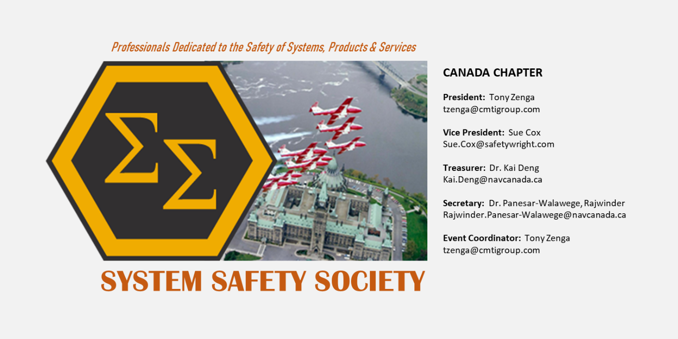

Title: Latest Thinking on Safety Case Arguments

Please join us on Wednesday, November 17th 2021 (12:00 noon - 1:00 pm EST) for an International System Safety Society Canada Chapter Presentation event featuring Mr. Chris Hobbs, Software Safety Specialist at QNX Software Systems, who will present Latest Thinking on Safety Case Arguments.
DESCRIPTION
The Safety Case, in which an organization lays out its argument and evidence for why it believes its system to be adequately safe, is becoming increasingly important. This is driven in part by the move from prescriptive safety standards towards goal-based ones, and partly because of the realization that the increasing complexity of our devices and systems means that the Safety of the Intended Functionality (SOTIF) is contributing to more accidents than component failure or malfunction.

Earlier this year, the Safety Critical Systems Club released guidelines on avoiding various forms of bias when preparing a Safety Case. Chris Hobbs was one of the contributors to that document and, during his talk, will give examples of when the preparation of a Safety Case has been disastrously inadequate, leading to multiple deaths, and what measures can be used to create a fair and honest Safety Case. Chris has also contributed to the latest version of the Goal Structuring Notation (GSN) standard, one of the notations used to capture the Safety Case argument, and he will describe those recent changes.

The area of Safety Case production is currently a subject of serious research, and Chris will conclude the talk with a discussion of possible new approaches to Safety Cases.
ABOUT Chris Hobbs
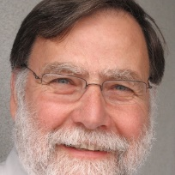
Chris Hobbs is an Ada and C programmer working within BlackBerry/QNX's team that develops QNX's operating system: an OS certified against IEC61508, ISO26262, EN50128 and IEC62304. He first met safety challenges as a junior software engineer in the late 1980s when he was inadequately prepared to answer a question about whether a product with a known safety defect should be shipped. He is the author of several books including Embedded Software Development for Safety-Critical Systems (second edition) and Flying Beyond: The Canadian Commercial Pilot textbook. His book, The Largest Number Smaller Than Five, a book about mathematical philosophy for young teenagers, sells less well.

Outside of work, Chris is a keen pilot and singer of Schubert Lieder, although not simultaneously.

MEETING LINK AND CALL-IN INFORMATION
Join Microsoft Teams Meeting (note if the “Join Microsoft Teams Meeting” hot link does not work please copy and paste the link at the bottom of this page in your Chrome browser)

________________________________________________________________________________
Microsoft Teams meeting
Join on your computer or mobile app
Click here to join the meeting
Or call in (audio only)
+1 647-484-5913,,487877296# Canada, Toronto
Phone Conference ID: 487 877 296#
Find a local number | Reset PIN
Learn more | Meeting options

It is recommended that you install the Microsoft Teams App about 10 minutes before the presentation.

Microsoft Meeting link:

https://teams.microsoft.com/l/meetup-join/19%3ameeting_OGFmOTI4NjEtZDg2OS00YTMyLWExNzYtNzdhNWY2MDZiMTkw%40thread.v2/0?context=%7b%22Tid%22%3a%2273e636be-e4d1-4bd4-9057-28cab8e7d4c3%22%2c%22Oid%22%3a%222ec7cf45-4172-409e-a48e-05257040b42c%22%7d

For the International System Safety Society Membership Information please visit:

https://system-safety.org/default.aspx

