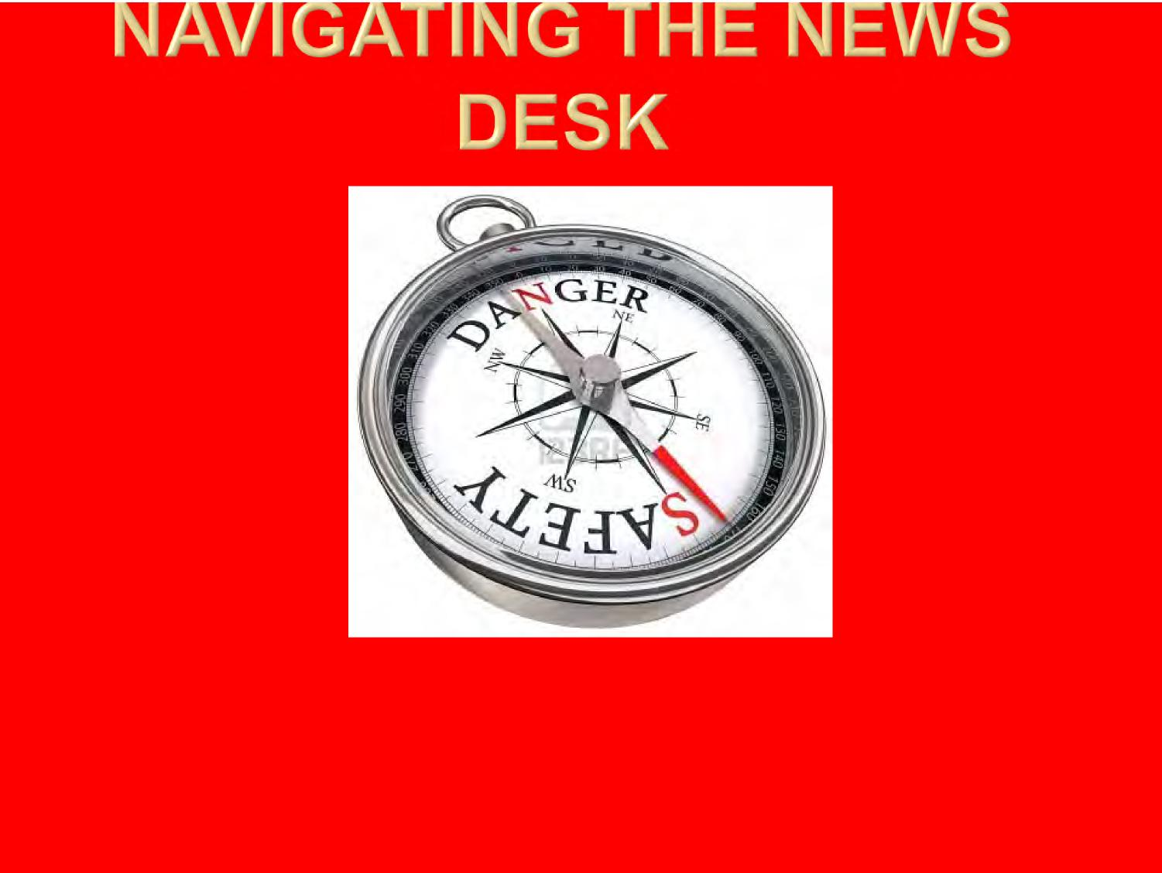

Ian MacLeod  
Ottawa Citizen  
Senior Writer

Presented to System Safety  
Society, Canada Chapter

Jan. 19, 2012

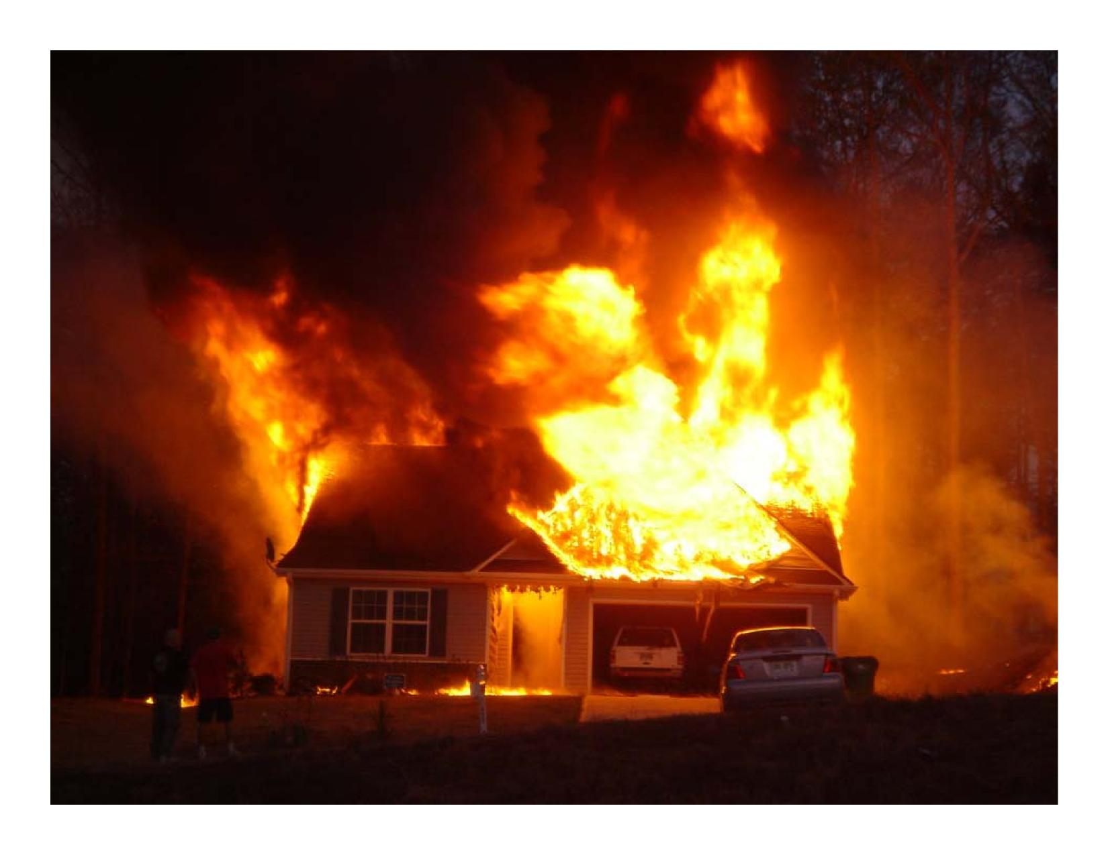

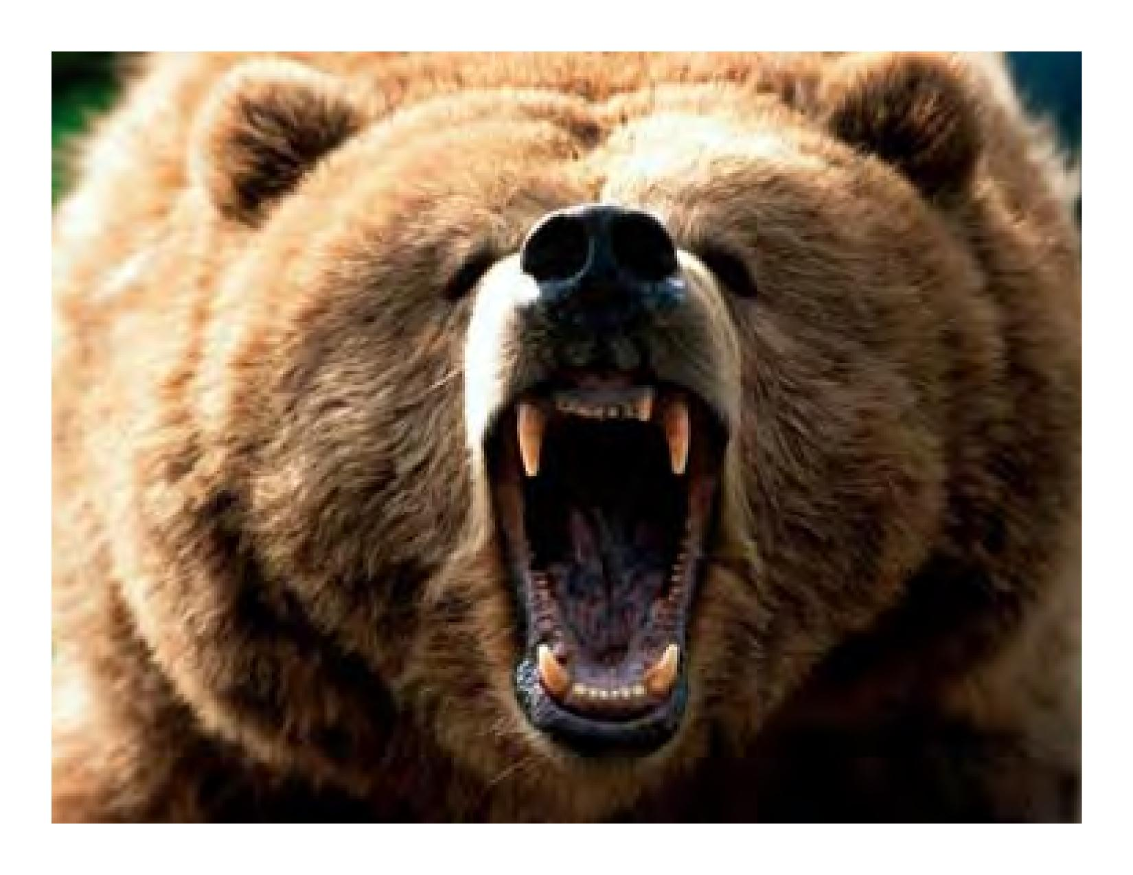

MANAGING THE MESSAGE:

How can safety practitioners

attract coverage without

sensationalizing the issue?

How can you control the

message?

How can you ensure fair and

accurate reporting of a

complex issue?

News Inc.

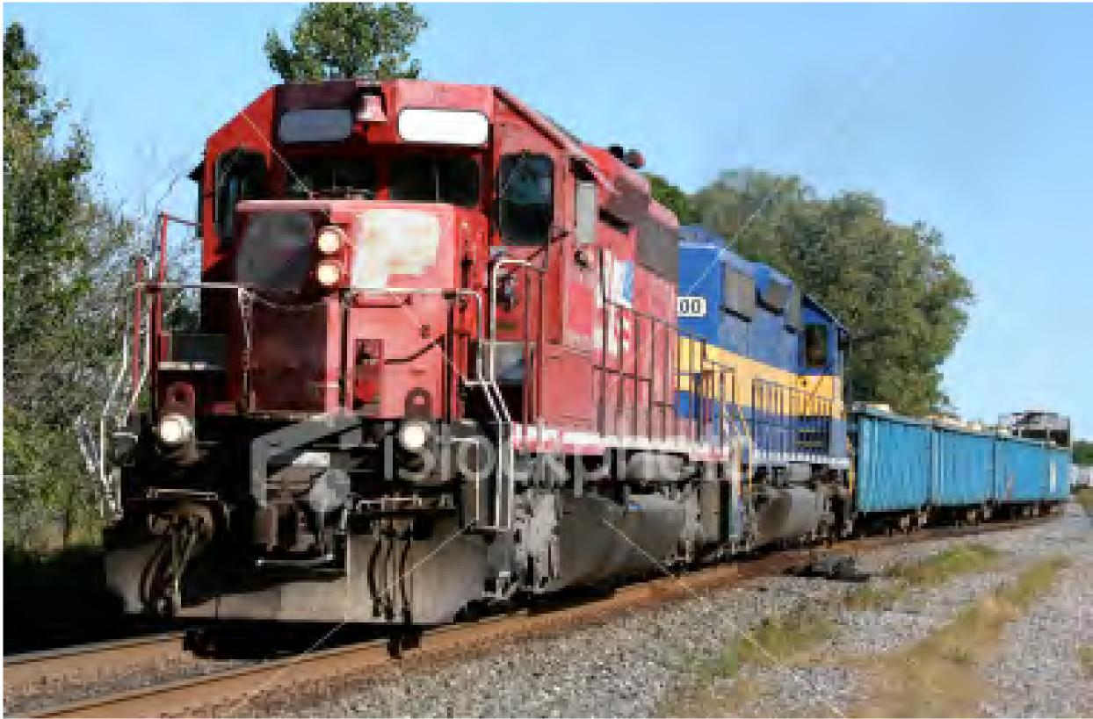

Feed the MONSTER





Unusual, infrequent event vs.

ordinary, commonplace.



*Man*

Bites

Dog

=

**News**

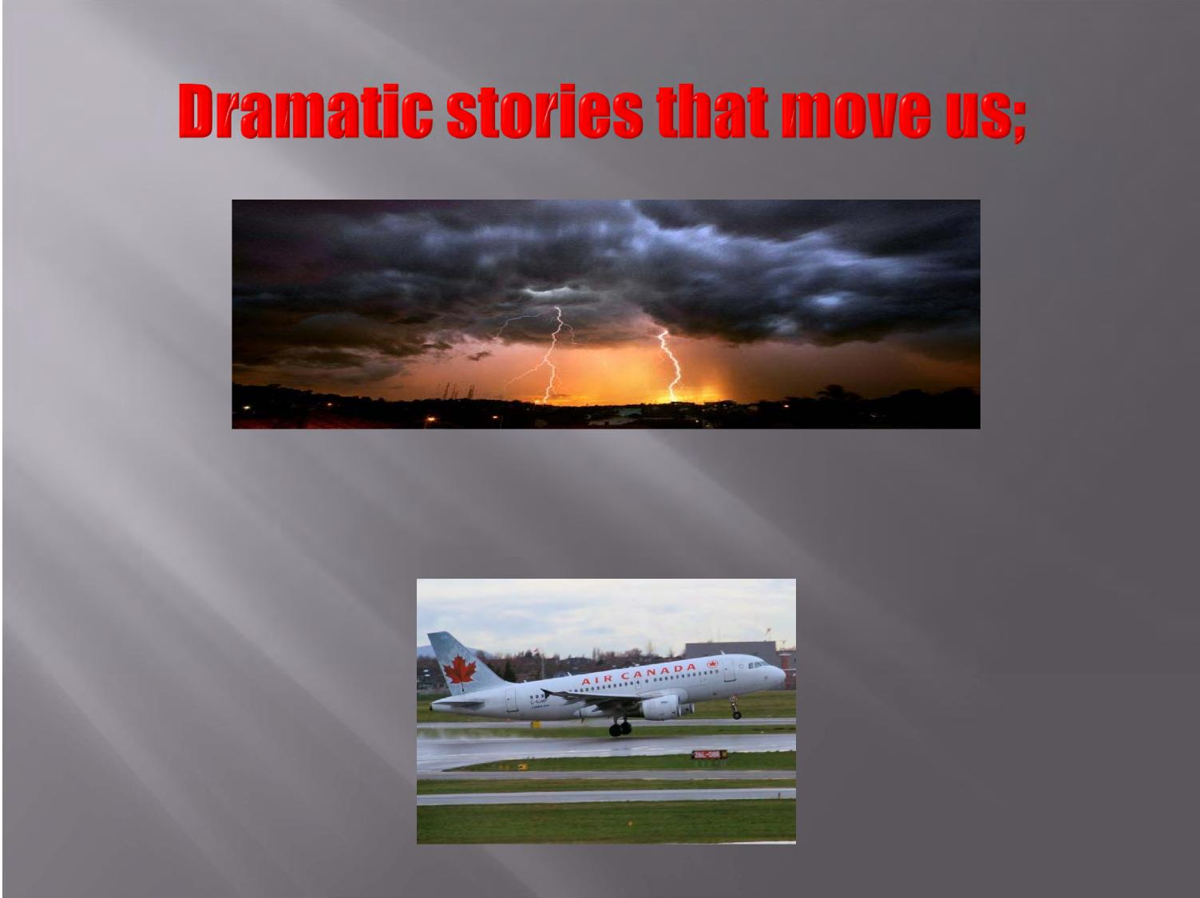

routine events and statistics do not.

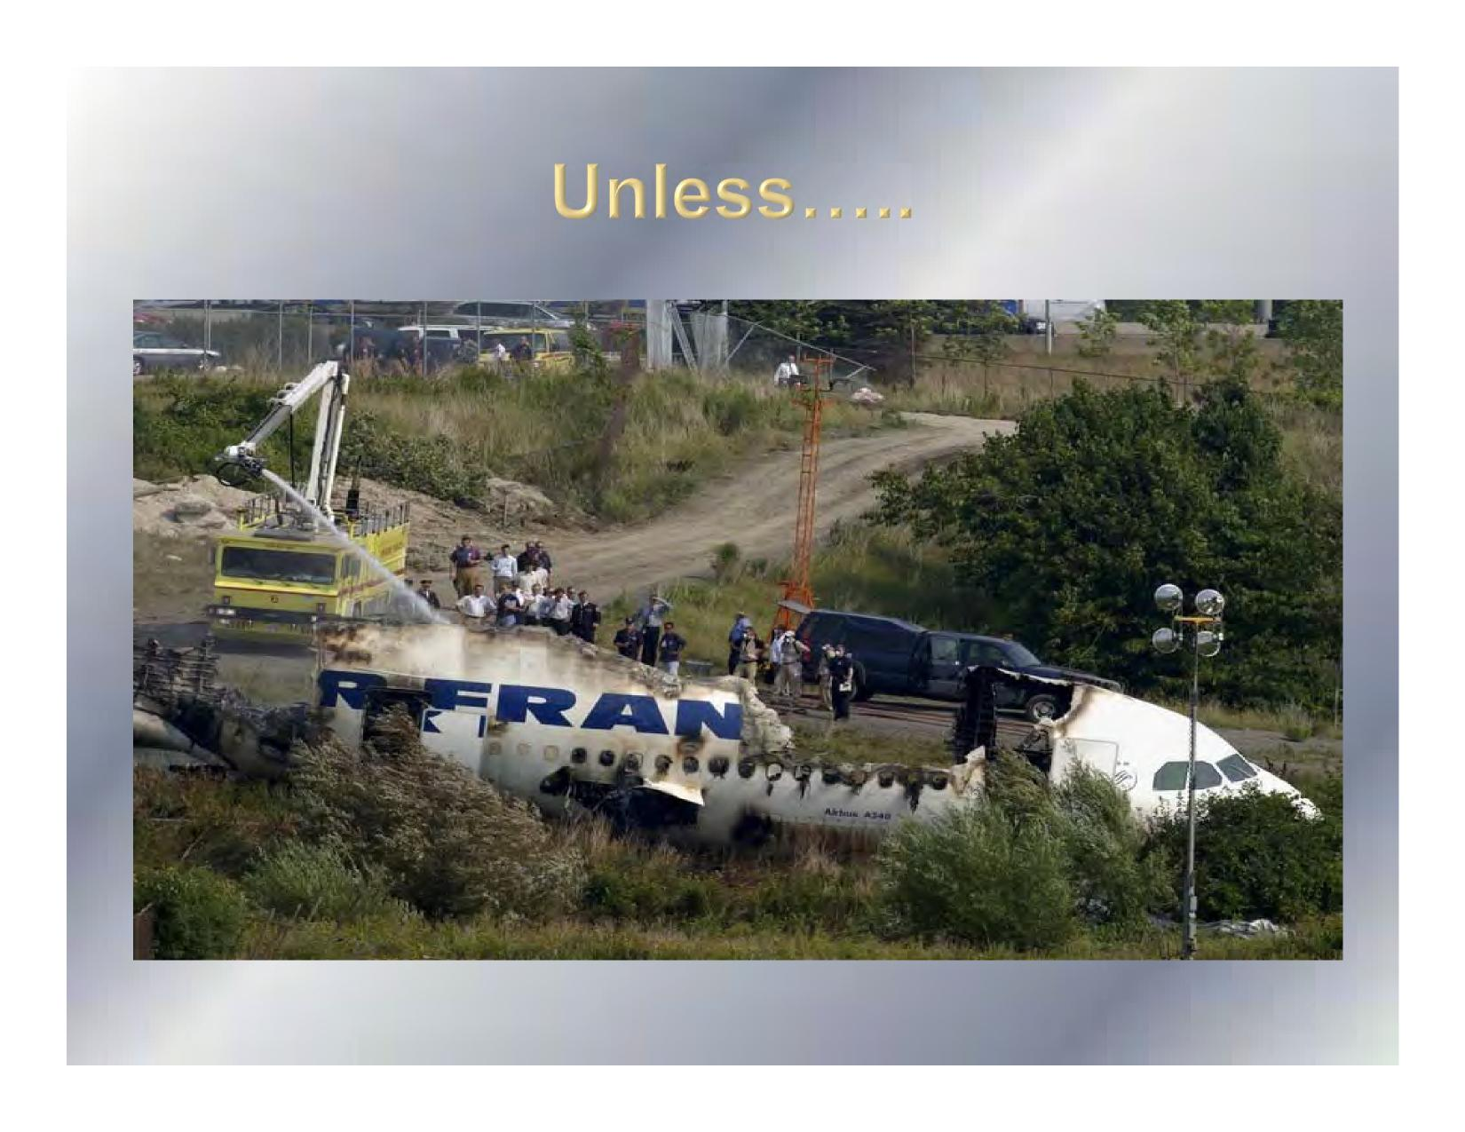

**,**

**DANGER**

Addicted to danger

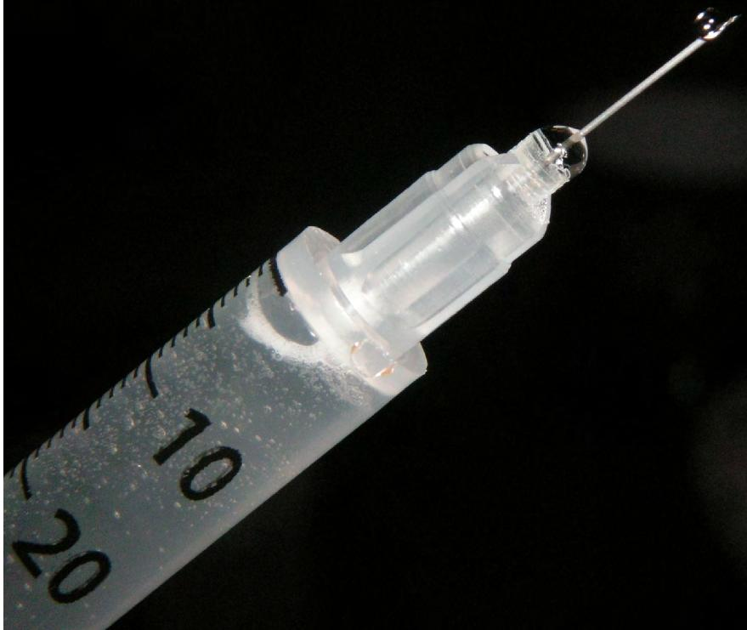



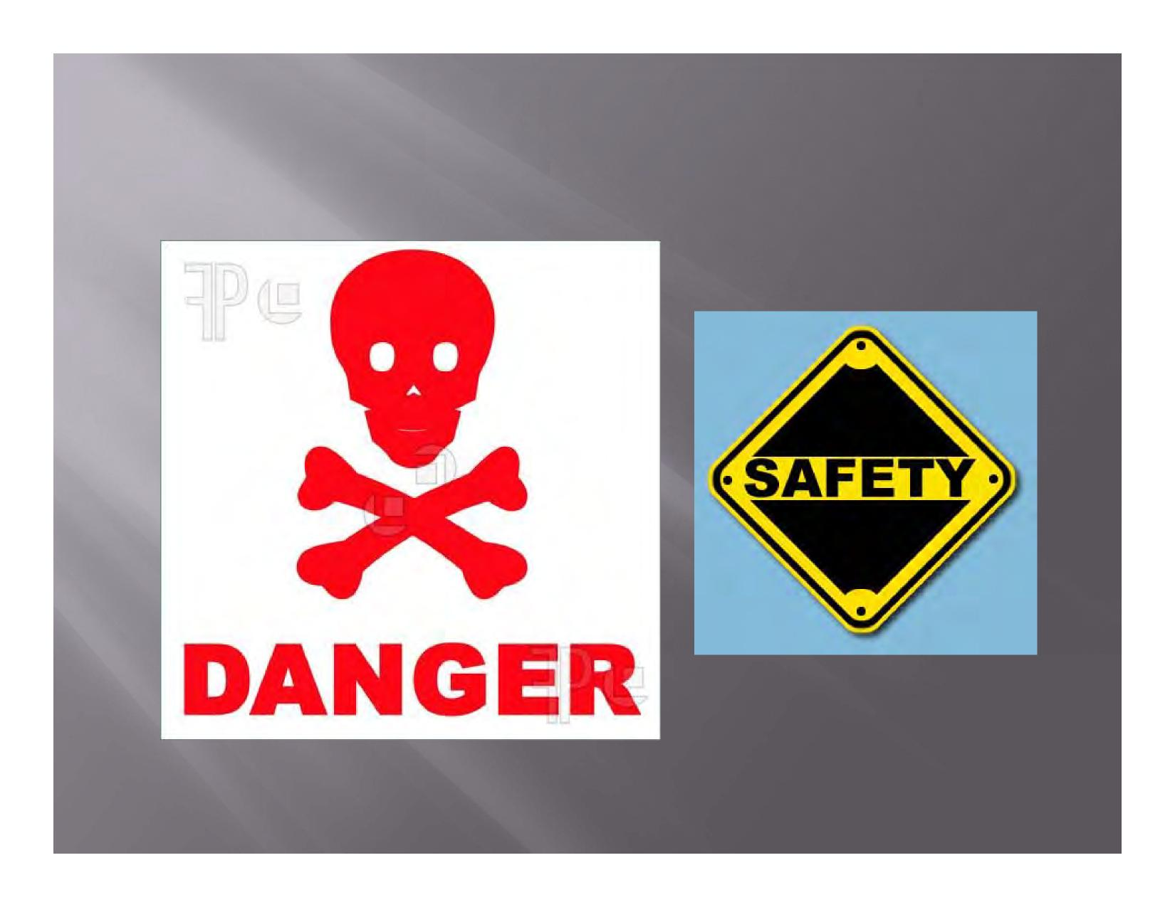

|  |  |
| --- | --- |
| **WHEN THE RUNWAY RUNS OUT** |  |



**The 24/7 news cycle pioneered by CNN has redefined news as something current**



**and HAPPENING NOW!**



WHICH OFTEN MEANS....

Issues that develop gradually and over time

– for example, improving safety trends –

are considered less newsworthy because they are

seen to have less ***impact****.*

**Nav Canada brings critical factor in near‑misses, collisions to crucial low**

**Airline safety among**

**best in world: study;**





Wed Apr 15 2009

Page: A6

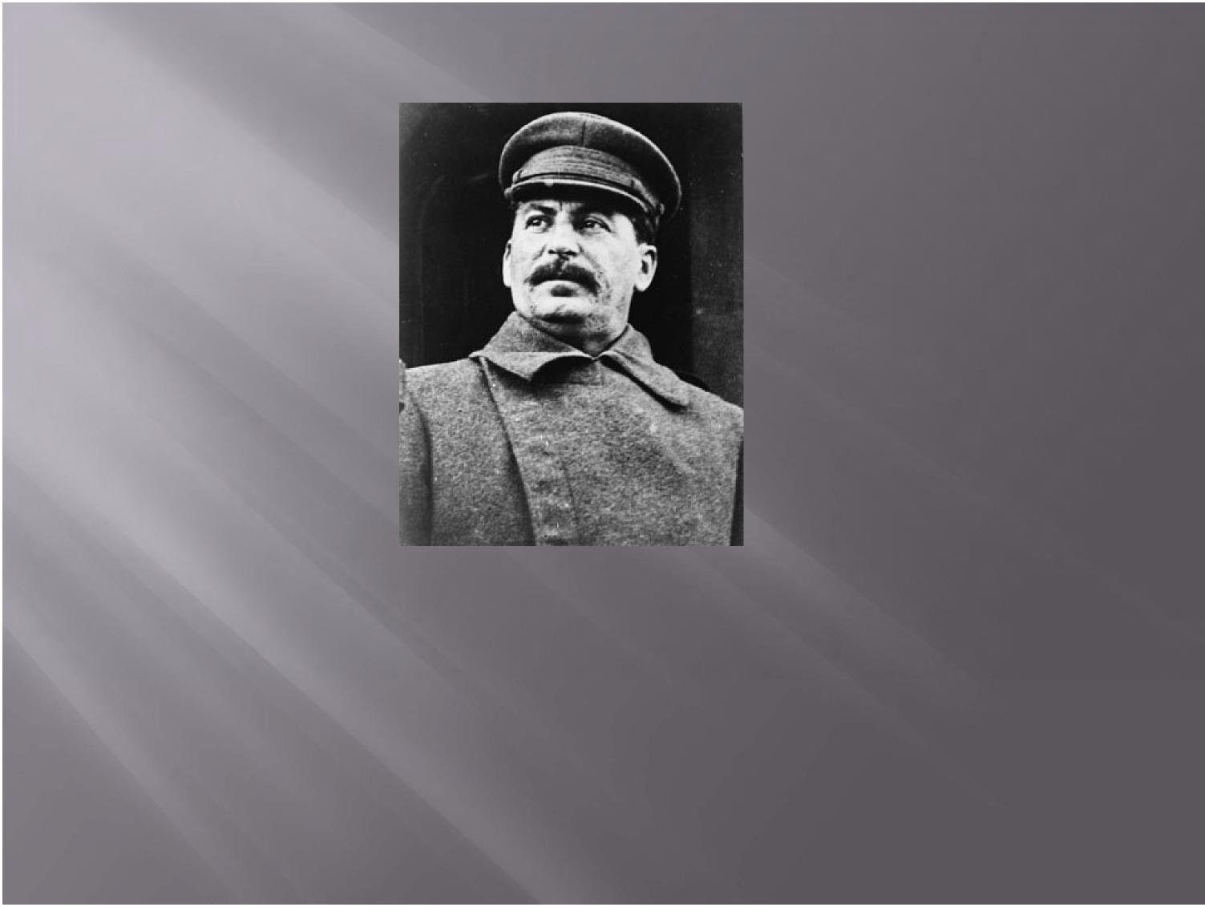

*A tragic death is a very dramatic story; a*

*declining death rate is just a number.*

- Joseph Stalin

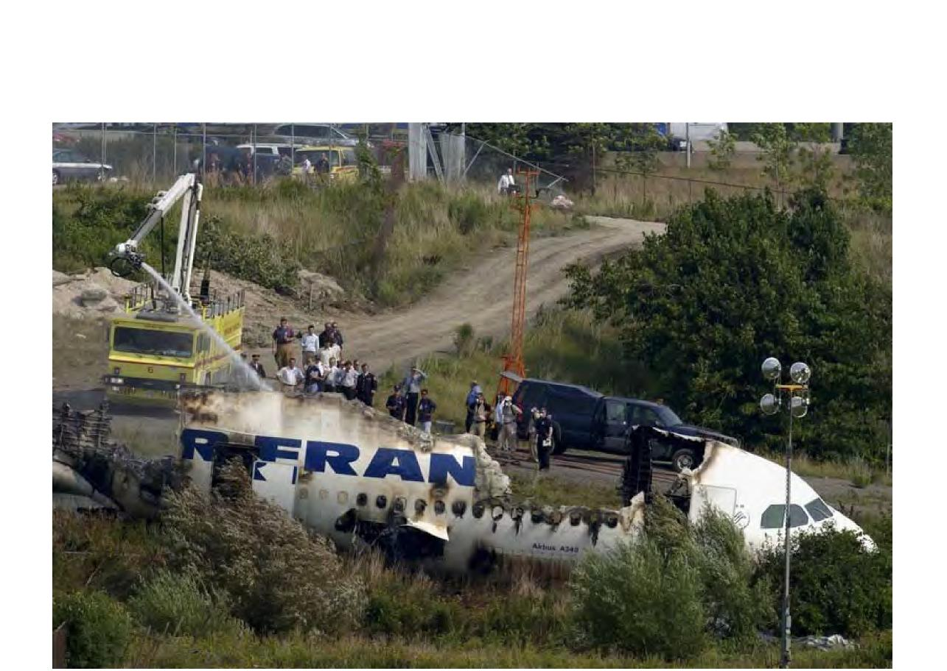

Rare events are skewed and appear

“normal”

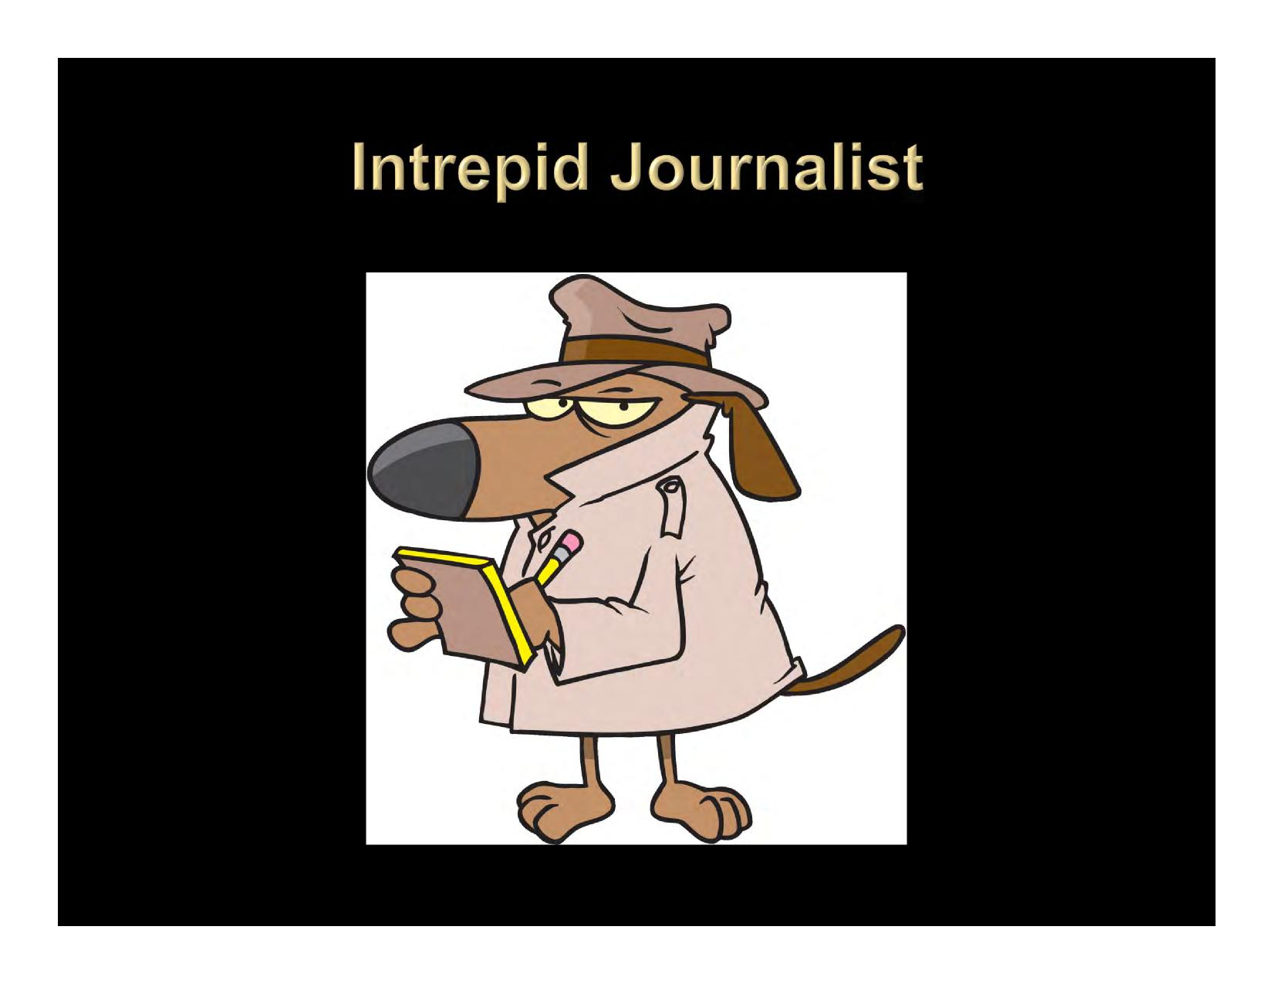

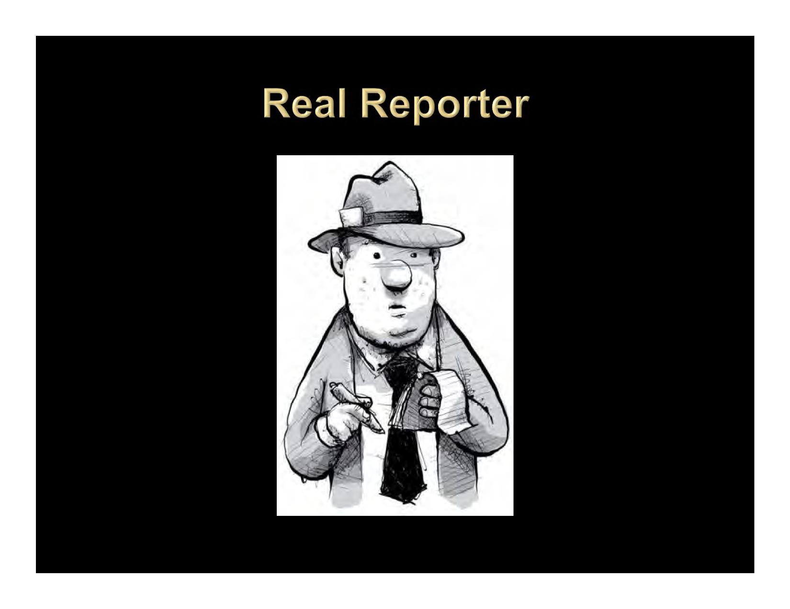



Black/white

Good/Bad

Triumph/Defeat

Success/Adversity

Half full/half empty

Love/Hate

Life/Death



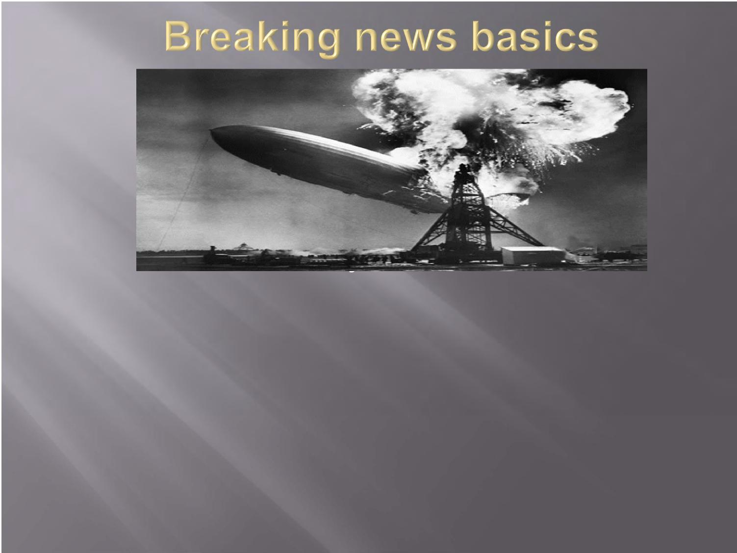

Be available

Keep it simple

No speculation?

Then offer insights: what will happen next, typical

areas for investigation, studies, research, etc.

Day Two

Advance the story

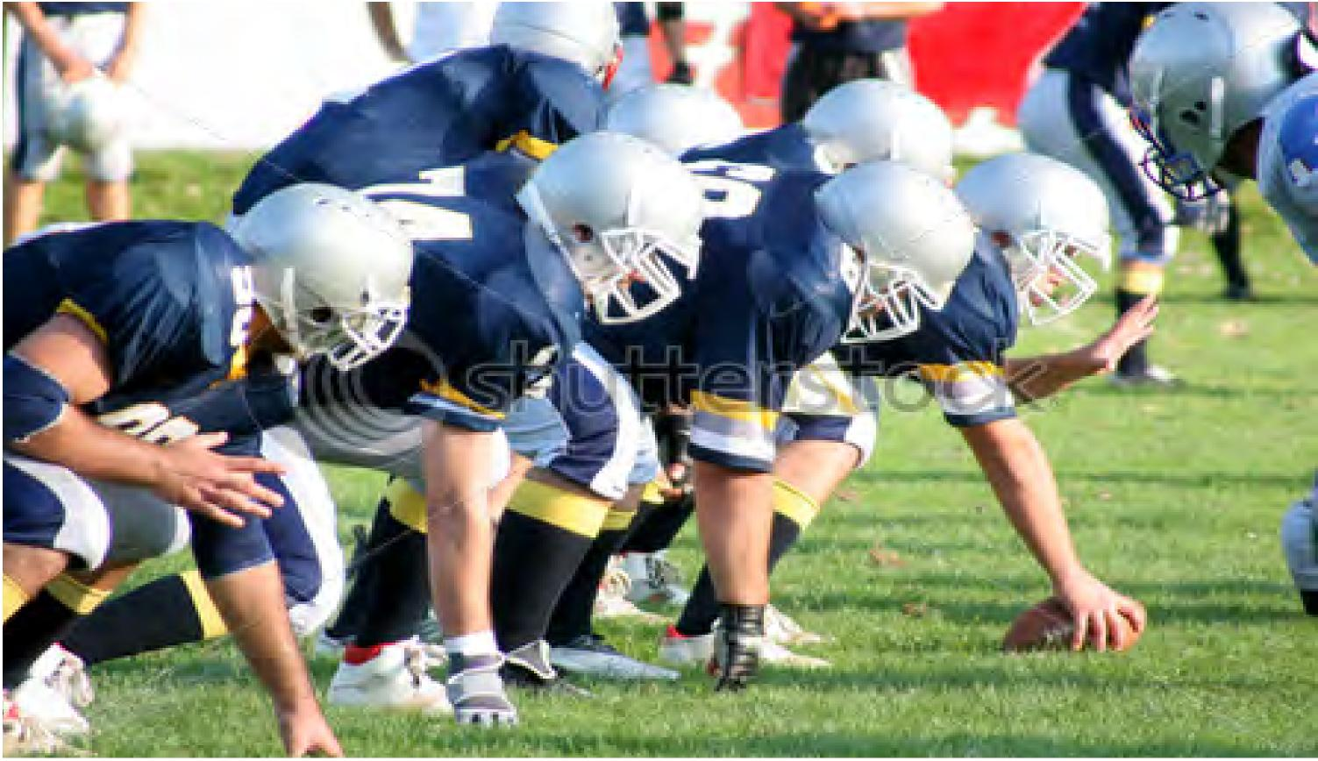





FILLTHE GLASS

with **information**

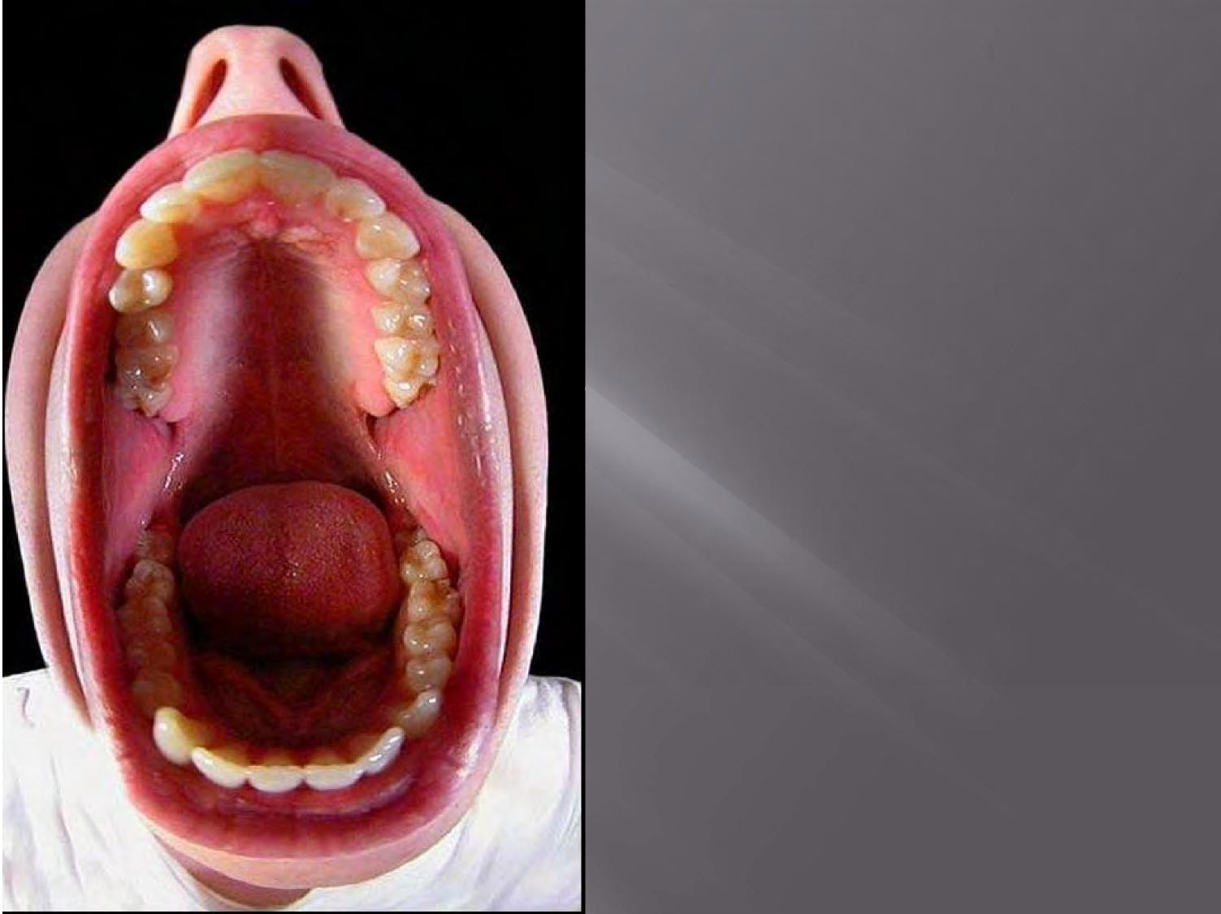

**The public is constantly**

**bombarded with**

**information and one of**

**the most effective ways**

**of cutting through all**

**that noise is to make**

**your message as big, bad**

**and scary as possible**.



**Handled**

**properly,**

**technology**

**can add**

**colour,**

**sophistication**

**and even**

**drama to a**

**story**.

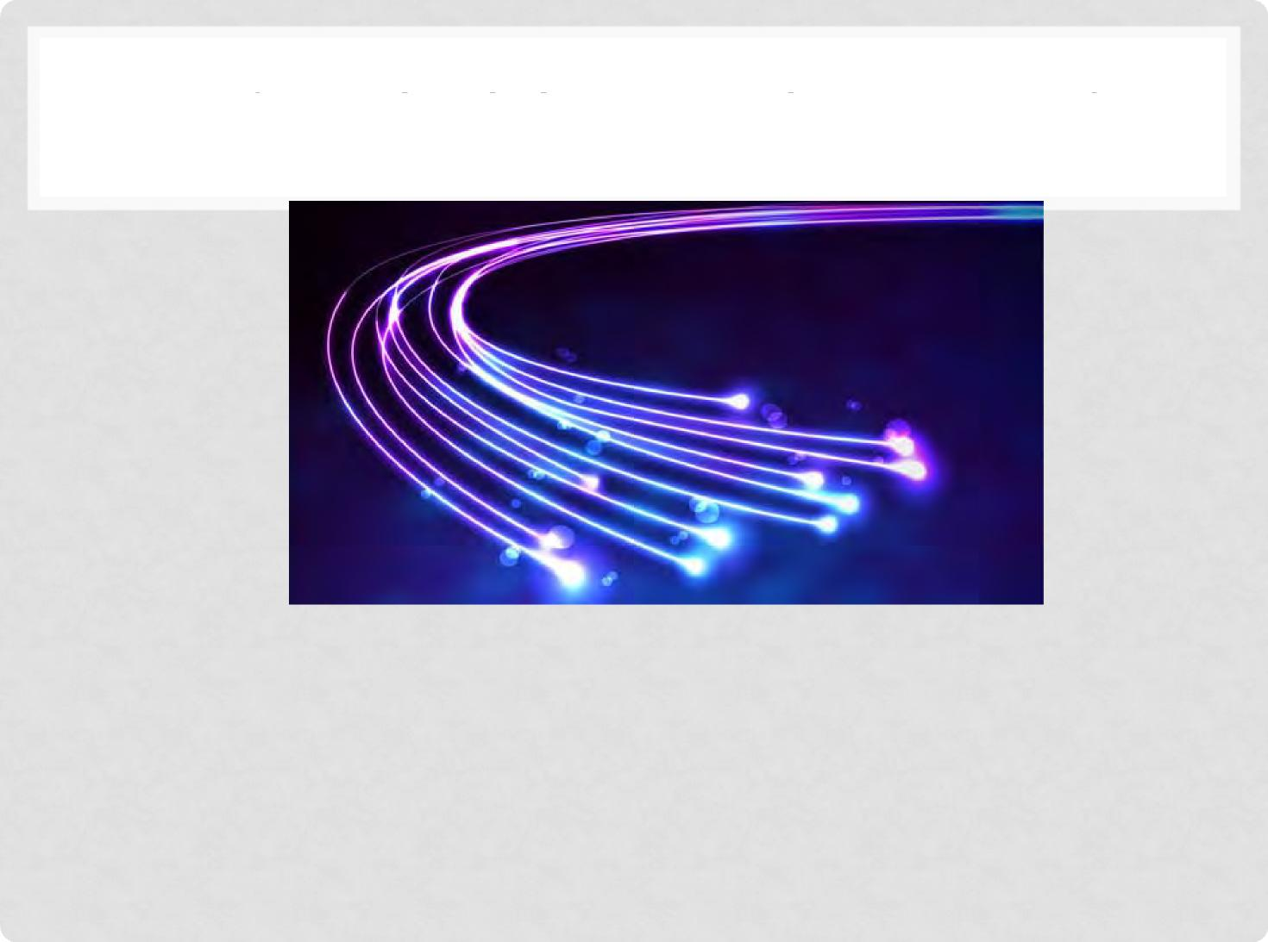

TECHNOLOGY = EDGY = NEWS

Will it save money, time or **lives** and make the world

safer?

Can we interview the inventor(s)?

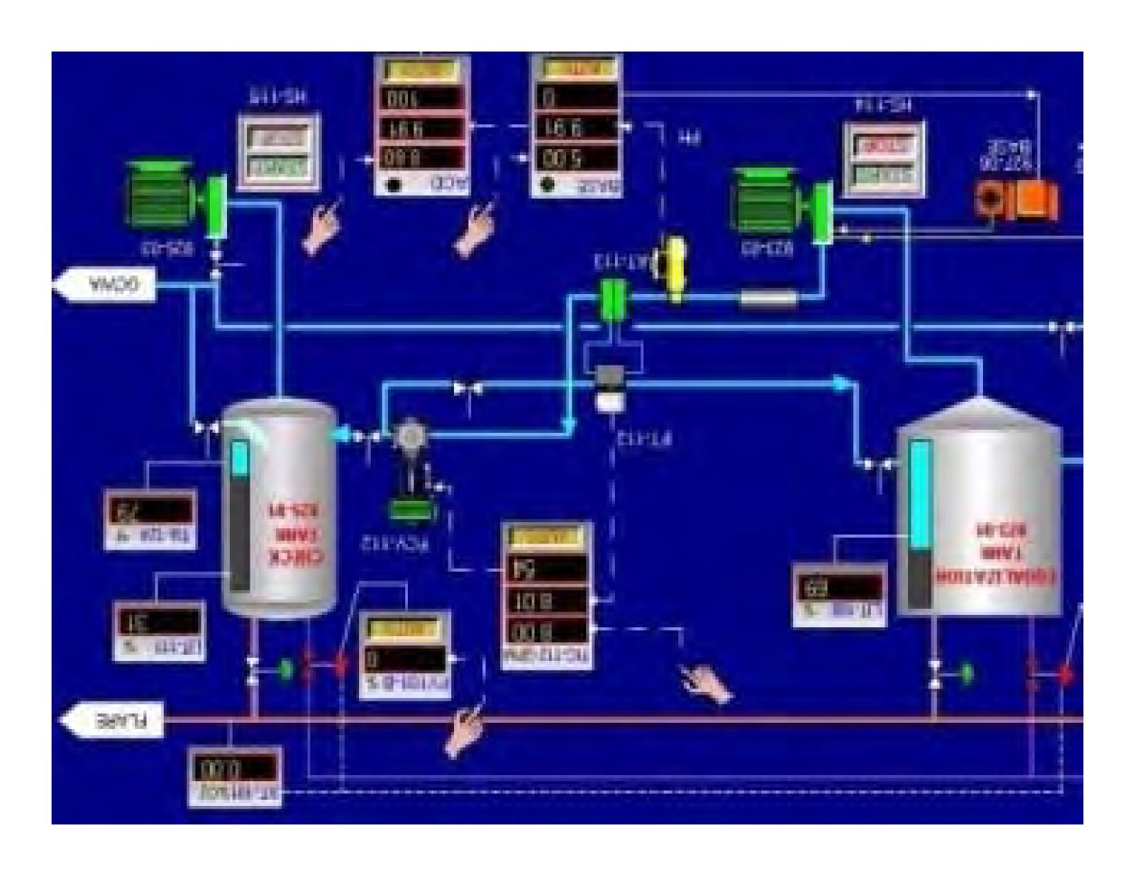

Keep it simple



**“FASTER, CHEAPER, SAFER;**

**MADE-IN-CANADA TECHNOLOGY IS READY FOR TAKEOFF**

**AND WILL TAKE AIR TRAFFIC CONTROL TO NEW HEIGHTS.**









**Anniversary  
Personalize**





We love lists



• “Canada's air, rail and

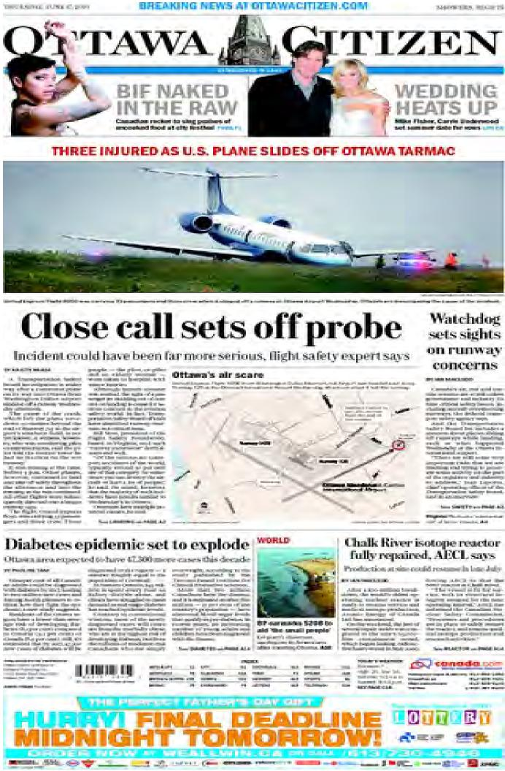

marine systems are at

risk unless government

and industry fix nine

critical safety issues,

including aircraft

overshooting runways,

the federal transport

safety agency says.”

How to ensure fair and accurate

reporting

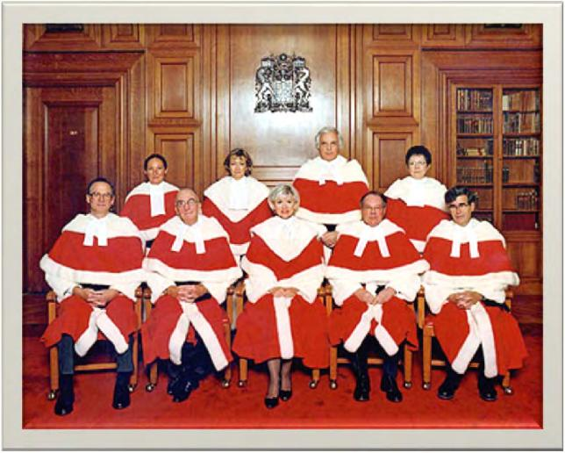

You Can’t.

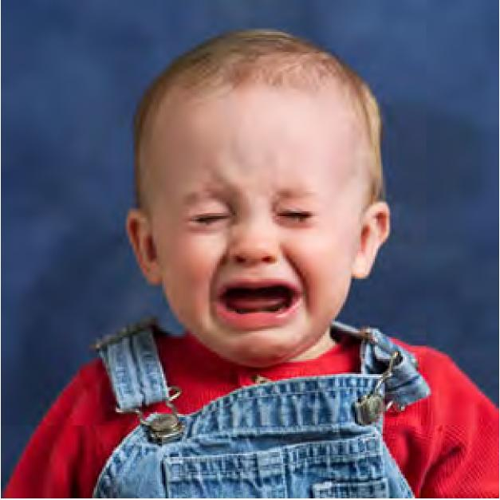



Unless the reporter is an

MIT grad, he/she should

have lots of questions,

including “dumb” ones.

Tech review of specific and

limited parts of the story.

|  |
| --- |
|  |

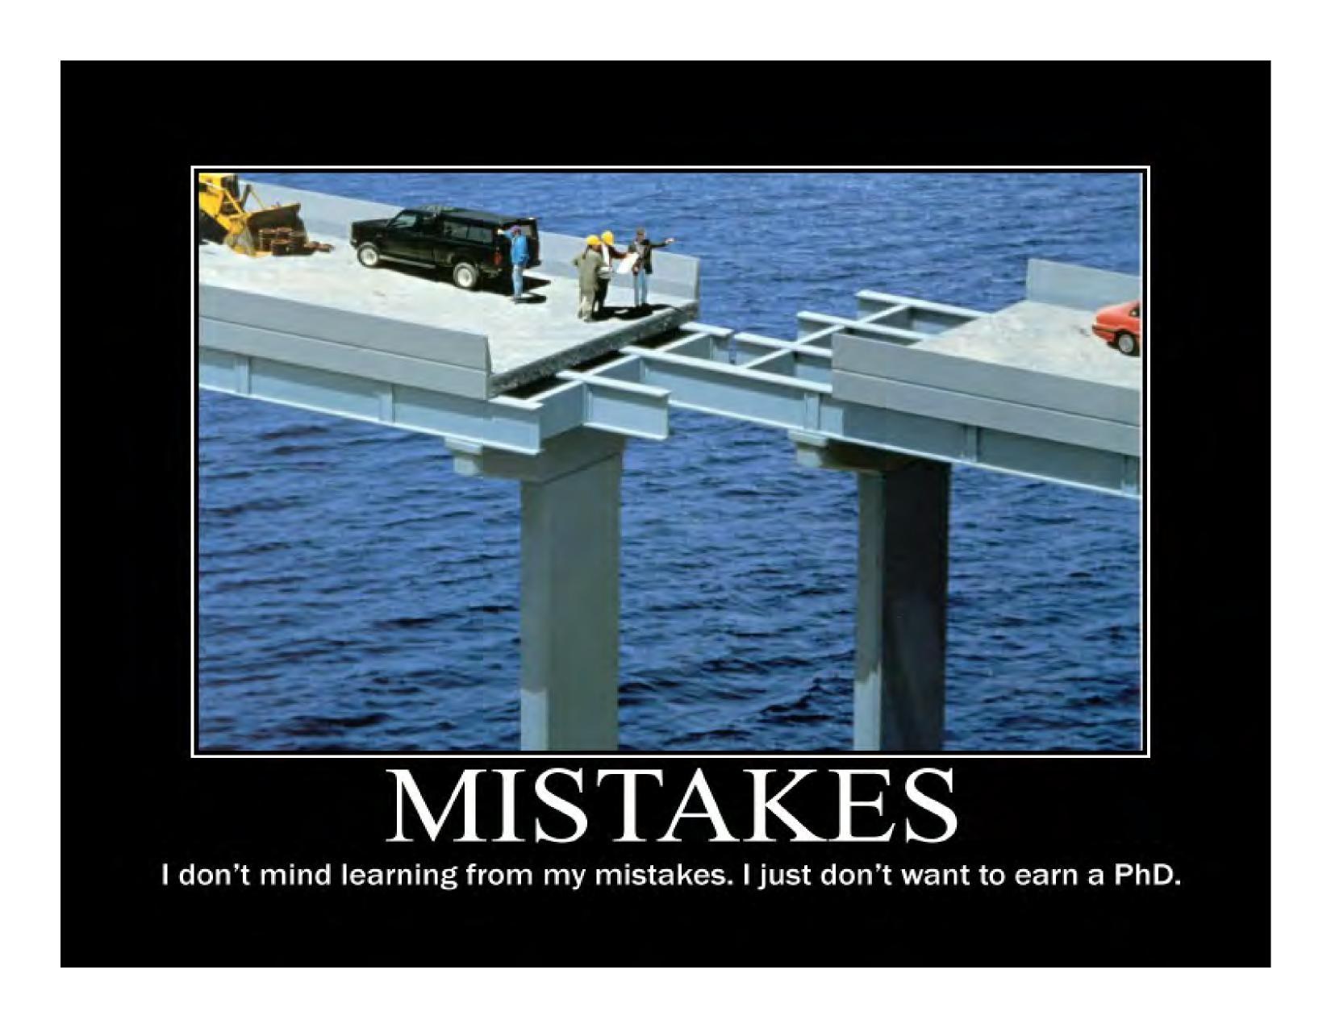

**I don't mind learning from my mistakes. I just don't want to earn a PhD.**

Call the boss

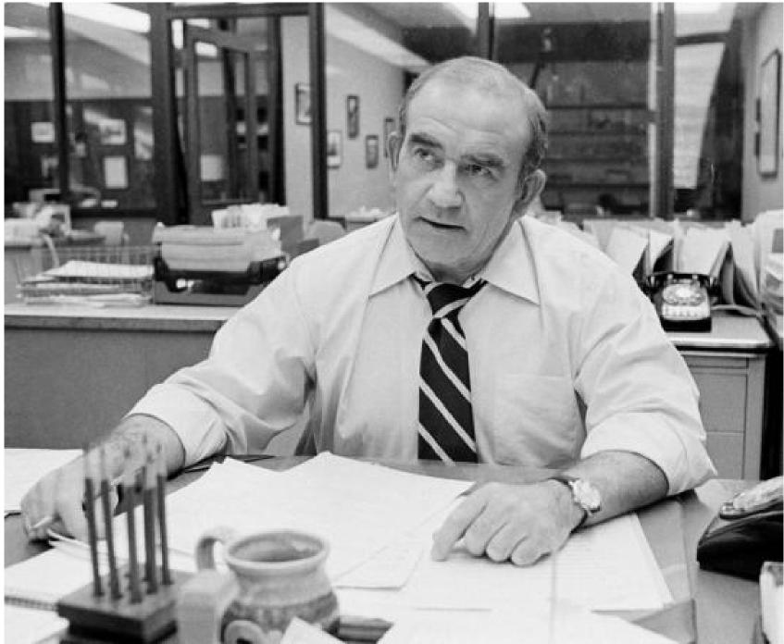

How can You control the message?



743kd

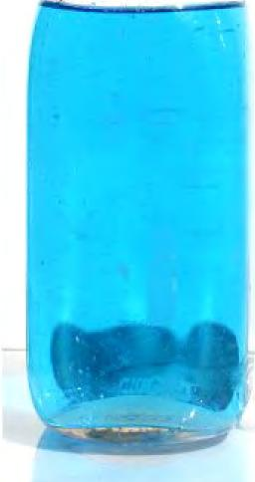

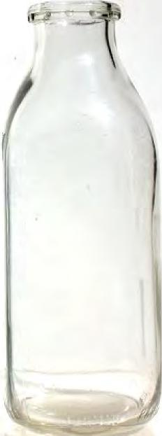

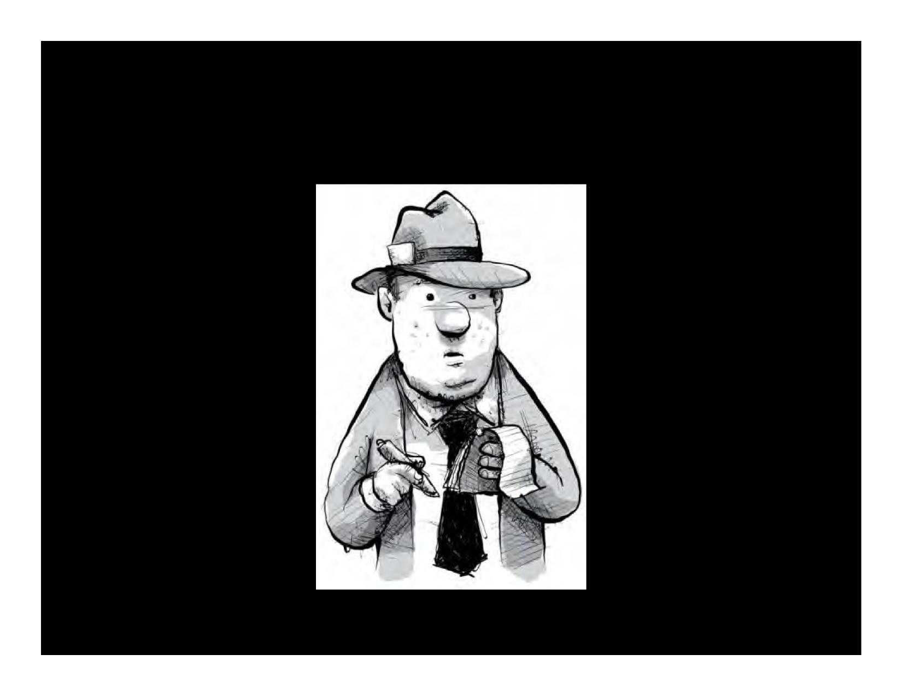

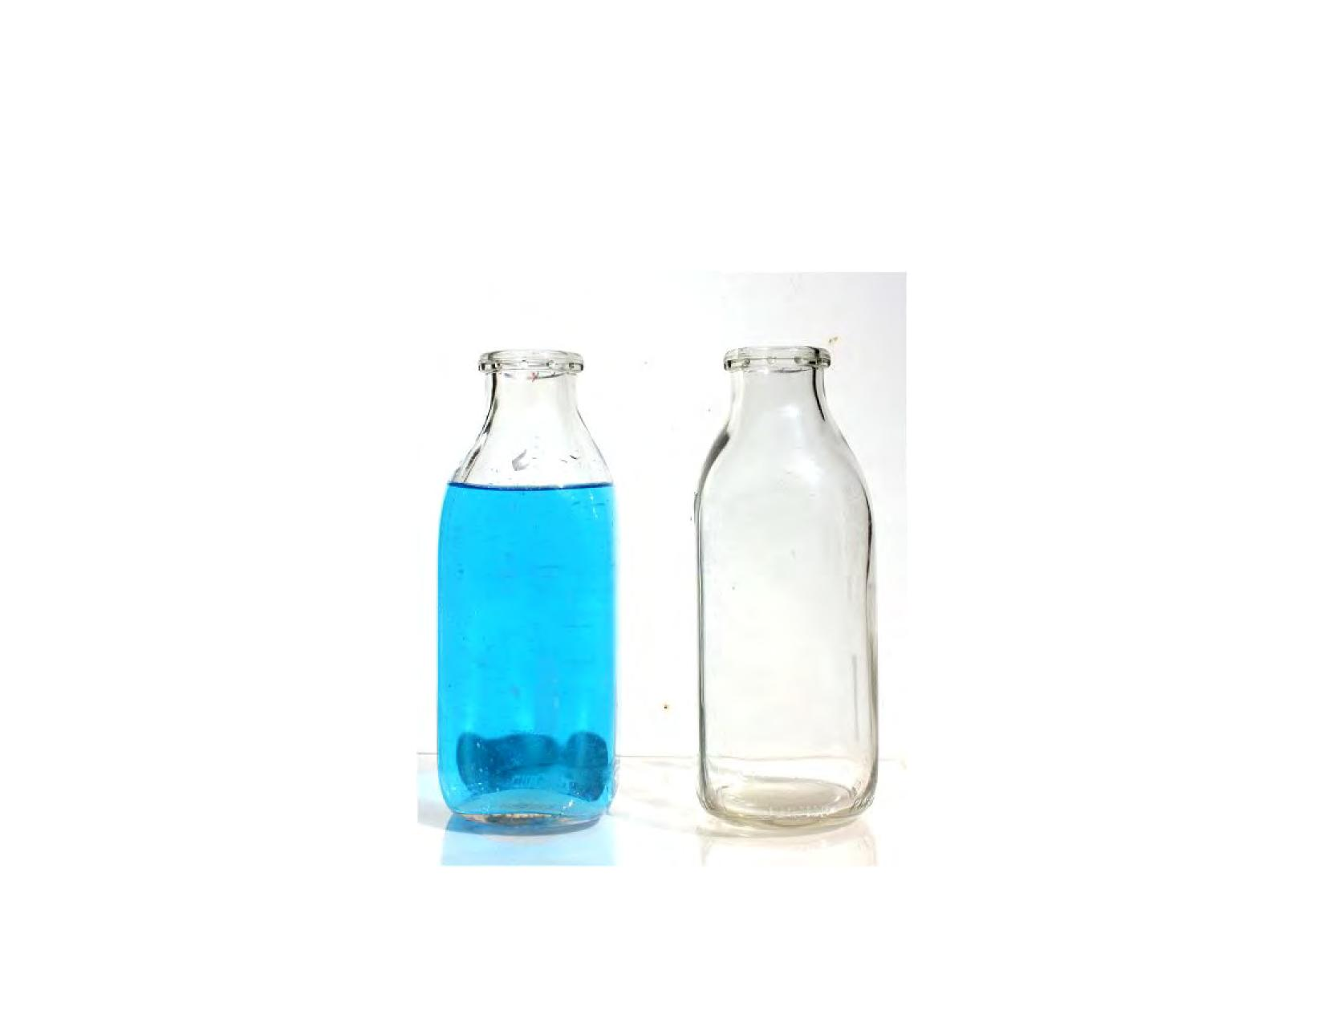

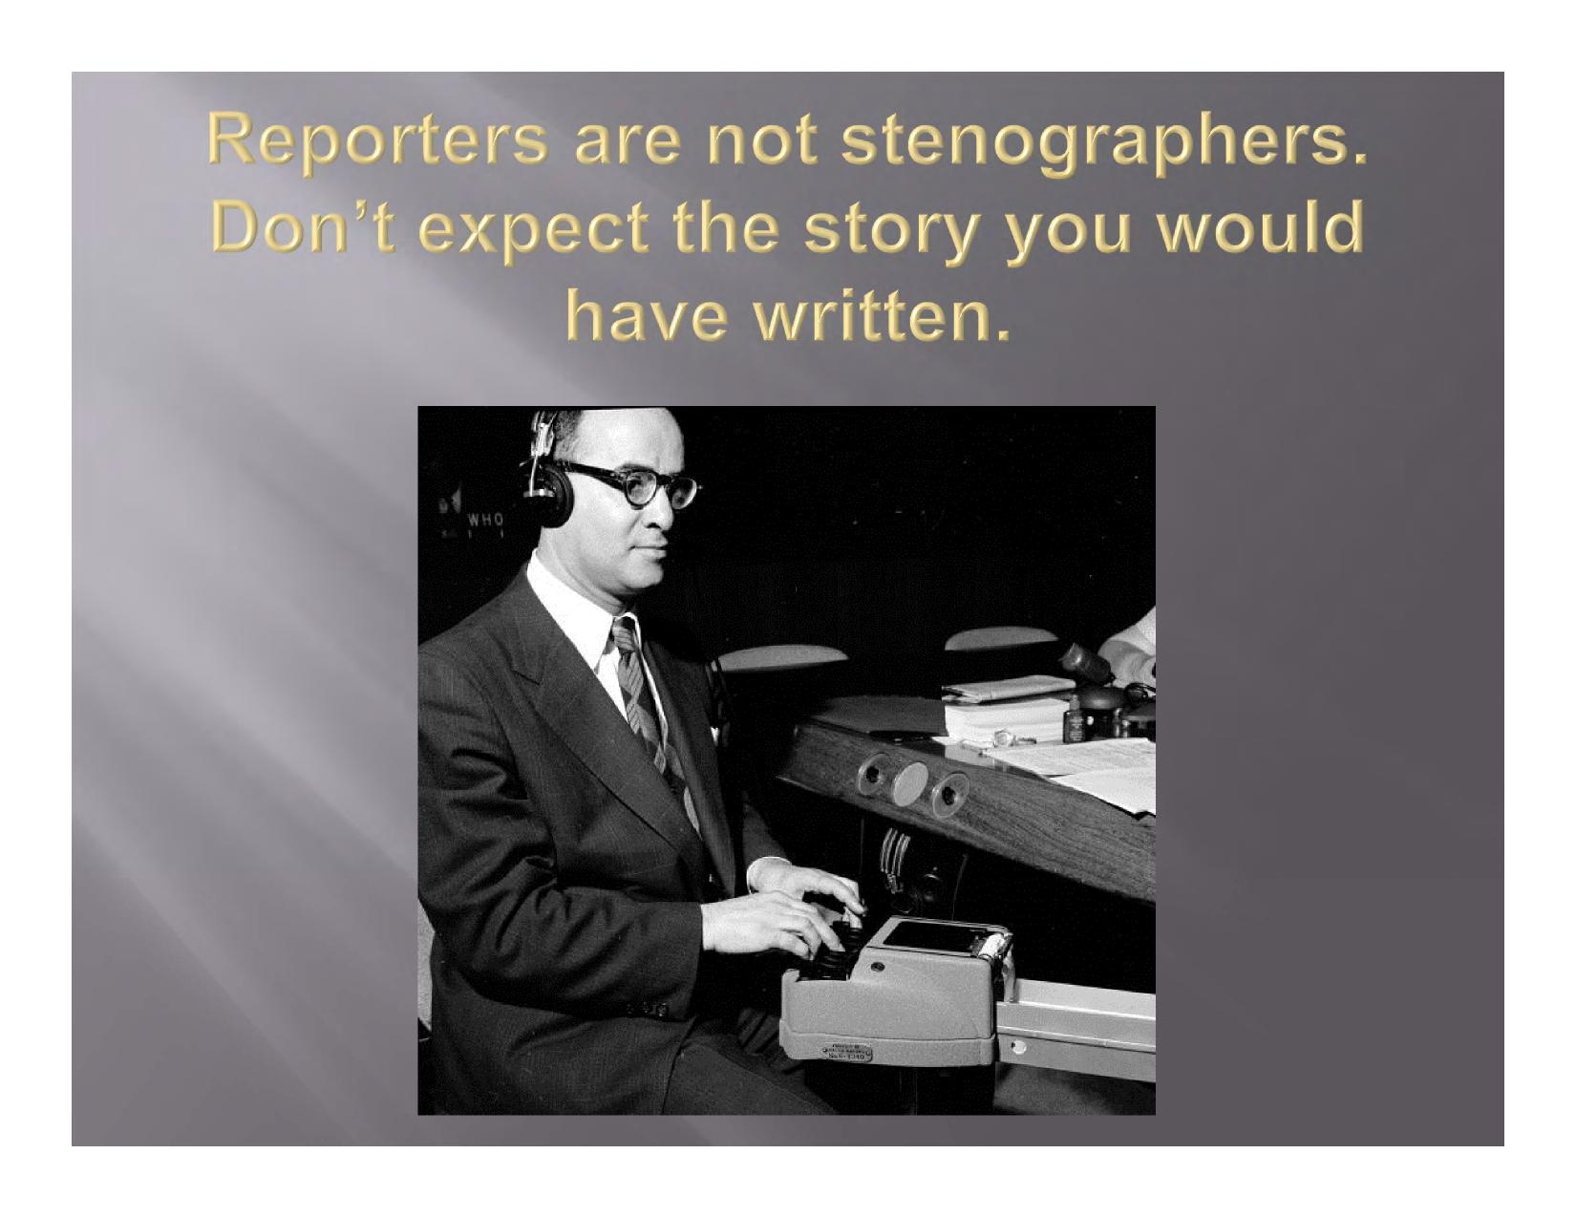

Reporters are not **stenographers.**

Don't expect the **story you would**

have written.

Even a positive story may be critical.

